Incident Lifecycle Automation in ServiceNow
Project Design Phase-II • Technology Stack (Architecture & Stack)
Phase 1: Requirement Analysis & Planning
Epic • Complexity: Medium • Duration: 1h 0m
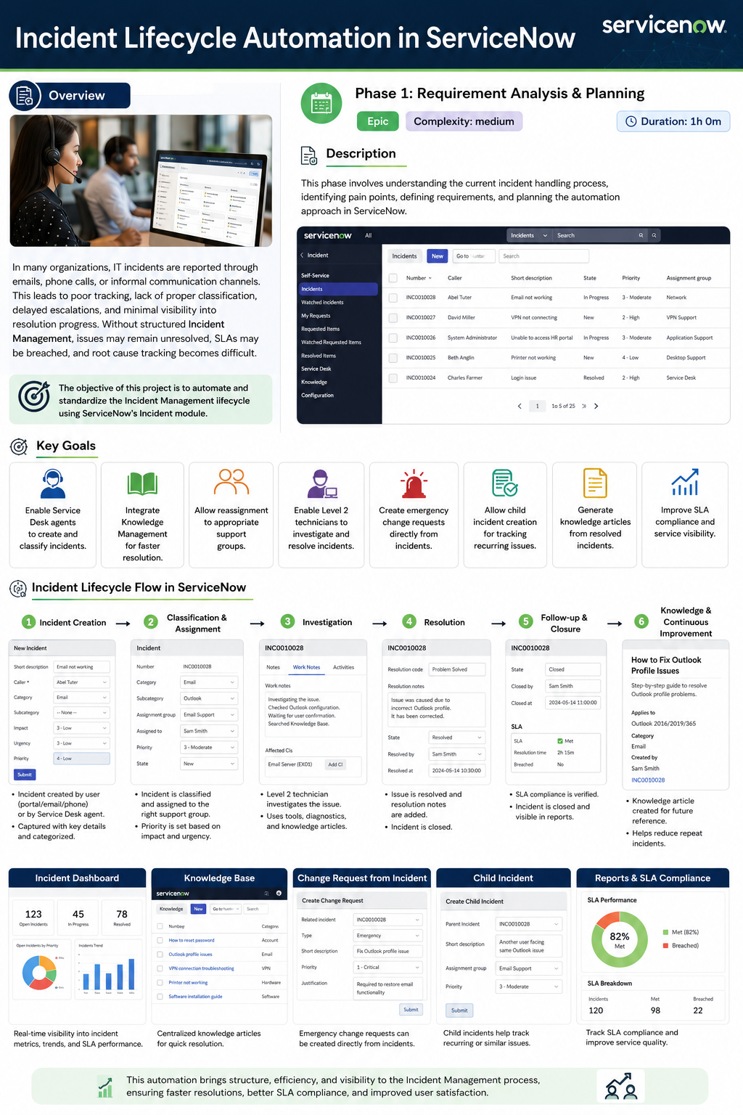

1. Overview
In many organizations, IT incidents are reported through emails, phone calls, or informal communication channels. This leads to poor tracking, lack of proper classification, delayed escalations, and minimal visibility into resolution progress. Without structured Incident Management, issues may remain unresolved, SLAs may be breached, and root cause tracking becomes difficult.
Objective: Automate and standardize the Incident Management lifecycle using ServiceNow’s Incident module.
Key Goals
• Enable Service Desk agents to create and classify incidents.
• Integrate Knowledge Management for faster resolution.
• Allow reassignment to appropriate support groups.
• Enable Level 2 technicians to investigate and resolve incidents.
• Create emergency change requests directly from incidents.
• Allow child incident creation for tracking recurring issues.
• Generate knowledge articles from resolved incidents.
• Improve SLA compliance and service visibility.
2. Incident Lifecycle Flow
Lifecycle Stage | Automation / Outcome
1. Incident Creation | Incident is reported by a user or Service Desk agent and captured with key details.
2. Classification & Assignment | Incident is categorized, prioritized, and assigned to the appropriate support group.
3. Investigation | Level 2 technicians investigate using diagnostics, work notes, and knowledge articles.
4. Resolution | The issue is resolved and resolution notes are recorded.
5. Follow-up & Closure | SLA compliance is verified and the incident is closed.
6. Knowledge & Continuous Improvement | Resolved incidents can produce knowledge articles for future reference.

3. Technical Architecture
The architecture below is presented as a ServiceNow-centered cloud solution. It maps the supplied template requirements to the Incident Management lifecycle, including user interaction, application logic, knowledge, change and child incidents, data persistence, integrations, and SLA visibility.
Components & Technologies
S.No | Component | Description | Technology / Platform
1 | User Interface | Service Desk and technician interface for incident creation, classification, investigation and closure. | ServiceNow web UI / Workspace
2 | Application Logic-1 | Incident creation, classification, prioritization, assignment, investigation, resolution and closure workflows. | ServiceNow Incident Management / Flow Designer
3 | Application Logic-2 | Knowledge lookup and knowledge-article generation from resolved incidents. | ServiceNow Knowledge Management
4 | Application Logic-3 | Emergency change and child-incident actions initiated from an incident. | ServiceNow Change / Incident capabilities
5 | Database | Incident records, work notes, assignments, SLA data and resolution details. | ServiceNow platform data store
6 | Cloud Database | Cloud-hosted persistence provided by the ServiceNow platform. | ServiceNow cloud platform
7 | File Storage | Attachments and supporting incident evidence, where required. | ServiceNow attachment storage
8 | External API-1 | Optional interface to enterprise notification or integration services. | IntegrationHub / REST APIs (if applicable)
9 | External API-2 | Optional interface to other enterprise systems for incident context or automation. | REST / SOAP integrations (if applicable)
10 | Machine Learning Model | Not mandatory in the supplied requirements; may be added for classification or recommendations. | Not applicable in current scope
11 | Infrastructure | Application deployment and hosting. | ServiceNow cloud platform

4. Application Characteristics
Characteristic | Description | Technology / Approach
Open-Source Frameworks | The supplied requirements do not mandate an open-source application framework. | Not specified
Security | Role-based access and controlled permissions should restrict incident creation, assignment, updates and administrative actions. | ServiceNow roles / ACLs / IAM controls
Scalable Architecture | A cloud platform supports standardized workflows across Service Desk and Level 2 support groups. | ServiceNow cloud architecture
Availability | Centralized cloud service provides shared access to incidents, workflows, knowledge and reporting. | ServiceNow cloud platform
Performance | Structured forms, workflow automation, knowledge search and dashboards reduce manual handling and improve visibility. | ServiceNow platform capabilities
5. Automation Use Cases
Knowledge Management: Agents can search existing knowledge during incident handling, while resolved incidents can be converted into reusable knowledge content.
Reassignment & Escalation: Incidents can move to the appropriate support group and Level 2 technicians for investigation.
Emergency Change: An emergency change request can be created directly from an incident when restoration requires a change.
Child Incidents: Child incidents can be created to track recurring or related issues while retaining the parent incident relationship.
SLA Visibility: Incident and SLA information can be surfaced in dashboards and reports to support compliance monitoring.
6. Expected Outcomes
• Standardized incident intake and classification.
• Faster resolution through knowledge reuse and structured investigation.
• Clear ownership and reassignment across support groups.
• Controlled emergency change and child-incident tracking.
• Better SLA compliance monitoring and service visibility.
• A continuous-improvement loop through knowledge articles generated from resolved incidents.
7. References
• C4 Model: https://c4model.com/
• IBM Cloud Architecture: https://www.ibm.com/cloud/architecture
• AWS Architecture: https://aws.amazon.com/architecture

